Ubuntu 22.04 ROS2 ISO Humble Upgrade Process
Clearpath Robotics online ROS2 Humble Upgrade tutorial
Items to check before upgrade:
- Verify Robot sensors are supported on ROS2 by Clearpath: Link If you have a sensor not listed, you will need to find the appropriate ROS2 drivers to install the sensor manually.
- Clearpath Navigation (ROS) software is not supported on ROS2.
- 32bit based processor PCs are not currently supported with Ubuntu 22.04
- Nvidia PCs are not currently supported with ROS2.
- Ethernet internet connection, not Wi-Fi. Your Robot PC should be able to ping www.google.com using ethernet.
- Before updating follow these steps to back up important files from your Ubuntu 20.04 ROS Noetic image:
https://docs.clearpathrobotics.com/docs/ros2humble/ros/installation/upgrading#saving-important-files
https://docs.clearpathrobotics.com/docs/ros2humble/ros/installation/upgrading#backup-software-ros-1-only
- Husky must use a Startech ICUSB232SM3 model Serial to USB cable between Husky PC and Husky MCU serial port
OS Installation:
- Download the latest Clearpath Robot Ubuntu 22 / ROS2 Humble ISO image: Link
- Make sure that the robot is connected to shore power, or that the battery is fully charged.
- Create a bootable USB flash drive using the downloaded ISO image using Rufus
- Connect a keyboard, a monitor, and ethernet internet connection to your robot's internal PC.
Make sure to note and unplug other ethernet devices from internal PC.
- Insert the Bootable USB into the Robot PC USB port - some USB ports can be disabled during OS installation - you may need to try a different one if it does not work.
- Access the Robots PC BIOs menu (press DEL or F12 repeatedly on PC power up) and select Boot, select USB - save and reboot the PC.
- Boot your robot PC from the USB drive, and let the installer do its work. If asked for a partitioning method choose Guided - use the entire disk and set up LVM.
- When prompted, set the username to administrator and the password (if requested) will be clearpath
- The setup process will be automated and may take a long time depending on your ethernet internet connection speed.
Once the setup process is complete, the PC will turn off. Please unplug the USB drive and turn the PC back on.
- Log on to the computer and run: bash -e clearpath_computer_installer.sh to install the needed software. This will take a while to complete and has prompts that must be answered. See below photos for prompts.
- Please follow the configuration instructions on the screen. If the computer reboots, wait for the PC to boot to the login screen, and re-enter the login credentials.
Post-Installation Configuration
- Set up Wi-Fi: Link
- Perform MCU firmware upgrade: Link Husky A200 does not have an MCU firmware update.
If access errors occur while upgrading firmware try adding the package server: https://wiki.ros.org/ClearpathRobotics/Packages
- Package Install: Package Sourcing, and Install Script: Link Command:
wget -c https://raw.githubusercontent.com/clearpathrobotics/clearpath_computer_installer/main/clearpath_computer_installer.sh && bash -e clearpath_computer_installer.sh
- Network Configuration: Link Set up the IP address for your Robot computer using Robot PC IP 192.168.131.1
- Create your Robot Yaml file: Link
Additional Robot.yaml file information: Link
Robot.yaml samples: Link
- Start Service: Link
Command: sudo systemctl daemon-reload && sudo systemctl start clearpath-robot.service
- Set up your remote PC: Link
- Sony PS4 Bluetooth Controller Pairing: Link
- Driving Tutorials: Link

Step 10 installation prompts
- Select the number that corresponds to your UVG model and press Enter.
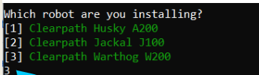

2. Enter the last 4 digits of your UVG serial number and press Enter.
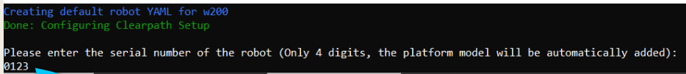

3. Would you like to install Clearpath services? Type y and press Enter.

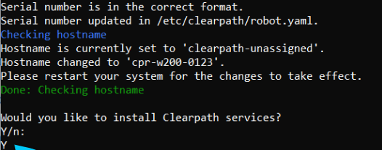

4. Type 'sudo reboot' to reboot the computer.
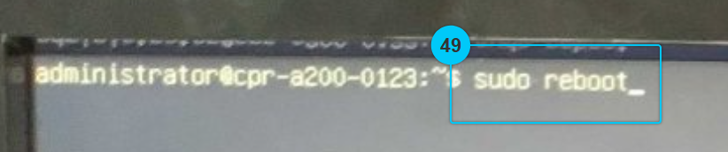

5. Once the computer has rebooted, log in again as the 'administrator' user.
Type 'sudo systemctl status clearpath-platform' and press Enter.
Confirm that the status is 'active (running)', then type 'q' to close the status check.

